Red and Black Jack

This activity is simple stochastic single-agent game that can be represented as a Markov Decision Process. Students will complete the state transition table and reward table for this game. Students will then perform value and policy iteration to identify the utility of each state and the best policy.

Rules:
- Setup
  - Put two red cards, two black cards, and one face card in a pile. Shuffle the pile. This is the Hit pile.
  - Put one red card and one black card in a pile. Shuffle the pile. This is the Stand pile.
- Each turn, the player has two action options: Hit or Stand
- On Hit, the player draws one card from the Hit deck. If the player draws the face card, they Bust and the game is over.
- On Stand, the player draws one card from the Stand deck and the game is over.
- Scoring
  - Scores are calculated based on the maximum number of any single color.
  - Bust: draw the face card = -5 points
  - Single: maximum of 1 of any color = 1 point
  - Double: maximum of 2 of any color: 5 points
  - Triple: maximum of 3 of any color: 15 points
  - Jackpot: Hit all cards except face card: 30 points

Defining the MDP:
States: Actions:

Transitions: Rewards:

Value Iteration
(0,0):
(0,1):
(1,0):
(2,0):
(1,1):
(0,2):
(2,1):
(1,2):
(2,2):
Single:
Double:
Triple:
Jackpot:
Bust:

Policy:
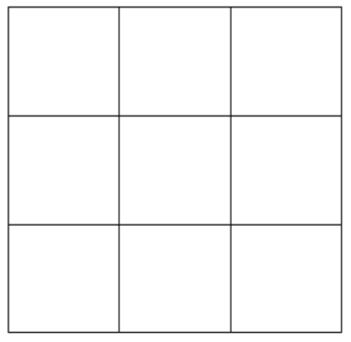

(0,0):
(0,1):
(1,0):
(2,0):
(1,1):
(0,2):
(2,1):
(1,2):
(2,2):
Single:
Double:
Triple:
Jackpot:
Bust:

Policy:

(0,0):
(0,1):
(1,0):
(2,0):
(1,1):
(0,2):
(2,1):
(1,2):
(2,2):
Single:
Double:
Triple:
Jackpot:
Bust:

Policy:

Step cost:
Policy:

Step cost:
Policy:

Step cost:
Policy:

Step cost:
Policy:

Step cost:
Policy:

Step cost:
Policy:

